Scrum week 4:

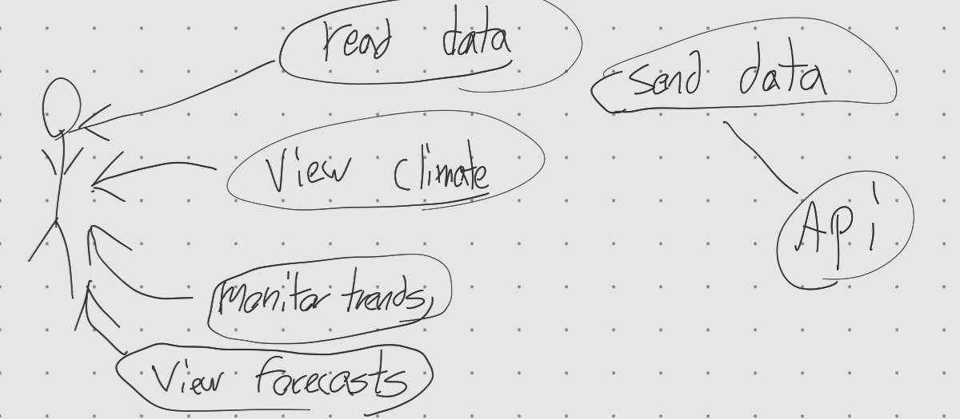

Tech Stack:

Front-end built on Flutter as a webapp for browser/pc/mac

Back-end: Environment Canada Realtime Hydrometrics API

App Goal: Create an app that aids “environment Canada” and others in monitoring water levels and climate at lakes across Canada.

App Requirements:

User:

* View Different lakes
* Runs in the browser
* Visualization of Data
* Download data
* Flag issues for management
* View Forecasts
* Query results are returned in JSON and Processed for the user
* User can search by
  + Location
  + Percentage dropped/gained over average
  + Low levels
  + Province
  + Station name/number
  + Weather attributes
* View Climate/Climate anomalies